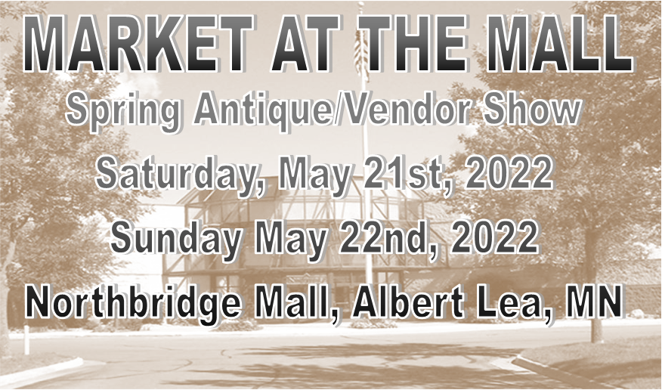
DETAILS
10 X 10 Booth is $50. You must set up both days!
Spots will be given on a first come basis! If you have a request for a spot please do so on your registration form. We will do our best to honor your request. The sooner you turn in your form the better your chances are for getting your desired location. Your booth will be marked with your name on Set-up day. Booth locations are determined by the event coordinators. The event coordinator reserves the right to make changes in booth locations if necessary.

6 Foot Tables are available for rent for $10 each on a first come basis, so please make sure and reserve them if you need them, they will NOT be provided unless you request and pay for them at this event.

Registration forms can be emailed to ddboutiquestyles@gmail.com or mailed to D & D Boutique, Northbridge Mall, 2464 Bridge Avenue, Albert Lea, MN 56007
SET-UP
Booths may be set up on Friday evening or Saturday Morning.
- Please move your car as soon as possible so others can unload.
- Do not drive on sidewalk to unload.
- Any walls or partitions used for display shall not exceed 7 feet in height.
- You are responsible for your merchandise.
- Please cover your merchandise in your booths Friday and Saturday evenings when you leave. (Any loss or damage that may incur is not the responsibility of the Event Coordinator, the Northbridge Mall Merchants Association, The Carrington Family Trust, or Francis Carrington.)

TEAR DOWN
Sunday at 4pm
- ABSOULUTY NO EARLY TEAR DOWNS! If you tear down early you will not be allowed to attend future events. When vendors tear down early this hurts the entire show, so please honor this rule.
- Remember this a 2-day show, please do not send in a registration form if you are not able to commit to both days!

ELECTRICITY $10
Limited availability, on first come basis please specify on your registration form if you need electric. We will provide cover for cords, NO DUCT TAPE!

SHOW HOURS
Friday - Set up
Saturday - 10 am - 5pm
Sunday - 12pm - 4pm

If for any reason you are unable to attend the event, please let us know immediately so we do not have an empty spot among other vendors and can make the needed accommodations. Your booth fee will not be refunded.
Questions? Email us at ddboutiquestyles@gmail.com

Please fill out the following form and return to ddboutiquestyles@gmail.com or mail with payment to: (payments must be received prior to show) D & D Boutique, Northbridge Mall 2464 Bridge Avenue, Albert Lea, MN 56007

Your name and your Business Name:

Address, City, State, Zip:

Email: Phone:

Type of items or service you plan to sell or promote, please be specific: (if you have a spot request, please specify here)

Booth Rental
10 x 10 $50____ 10 x 20 $100 ___

Table Rental $10 each.
Tables will not be provided for this event. Tables are limited, so make sure and reserve your tables!!! (You can bring your own tables)
I need _____ tables at $10 each = $_____

Electric $10 (Limited Electric Spots are available.)
Bring your own heavy-duty extension cords. The mall will provide rubber strips for the carpet. NO DUCK TAPE PLEASE! ____ Yes I need Power and am enclosing the $10 fee. ____No I don’t need Power

Total Due/Enclosed: $
Cash, Checks, Venmo, PayPal and Cash App Payments accepted. Please message us for details.
Your registration is not confirmed until payment is received!

Please send us a copy of your MN TAX ID. If you do not have a Minnesota Tax Identification Number, and just do these events on an occasional basis, pleases complete the MN ST19 form and turn in prior to the event. The form can be found at: https://www.revenue.state.mn.us/sites/default/files/2011-11/st19.pdf

If for any reason you are unable to attend the event, please let us know immediately so we do not have an empty spot among other vendors and can make the needed accommodations. Your booth fee will not be refunded. Should the show need to be cancelled by the Northbridge Mall for any reason, at any time, this contract is null and void. Exhibitors waive any and all claims except booth rent.

Hold Harmless Agreement
I agree to indemnify and hold harmless, Northbridge Mall Merchants Association, Amy Wangsness, D & D Boutique, Tami Riecke and The Carrington Family Trust against any and all claims, or liability that may arise as a result of my entry in this show. I have read the enclosed rules and regulations and understand my responsibility to comply with said rules and regulations, set forth.

Signature:_________________________________________________________________

